**ALGORITHM DESIGN AND ANALYSIS (SE- 303)**



**DELHI TECHNOLOGICAL UNIVERSITY(DTU)**

**PROGRESS REPORT**

**ON**

**TOPIC: STARTUP WEBSITE**

**SUBMITTED BY:**

**ASHISH KUMAR (2K18/SE/041)**

**ANMOL YADAV (2K18/SE/028)**

**INTRODUCTION**

This project focuses on building a website for an emerging startup, which aims to provide people with one stop destination for good quality websites on demand and provides a user-friendly experience.

The website provides an interactive experience where the user can browse through the services provided, look at our previous projects and websites made and contact directly through email, if interested in expanding their business with us.

Website’s graphical interface keeps the user interested while providing with all the important details about the work.

This website is the initial interaction front of the startup.

Developer, whose interest lies in working with our company, can also apply for the same through this website itself.

**PROBLEM STATEMENT**

As everything is digitalizing in this era, businesses need an online handle too.

Considering that without a website, blog, or online presence prospective, clients could begin to wonder how serious you are about business. Today, all companies (whether it is a small or big company) and industries are establishing a successful online presence.

Not having an online presence can make clients not taking you seriously and you could end up losing them and even your business also.

Websites can operate 24x7 to answer any queries and generate leads (or sales), thus helping to channel more clients and reduce the workload of staff.

With an online presence, you can give the customers just the information, that what they are looking for. This means fewer phone calls with technical questions resulting in more sales and profit. You can spend more time working on the revenue generating activities in your business and spend less time handling common customer service issues.

If you are already selling offline, then the transition can be very smooth. In online, you continue selling the same products that you know and have a good supply of very easily. Putting your company online simply gives you a new source of customers.

**PROPOSED SOLUTION**

In this era of technology where more and more companies are establishing their online presence, not having a website, blog or online handle can degrade the company image.

Having a website reduces a lot of workload and expenditure, also reducing the staff requirements and thus increasing profits by reducing the cost of running business.

Websites runs 24x7, which means customers would always have access to exactly the information they are looking for at the instance. Having a website can potentially attract more customers and hence help generating more income.

For people already selling offline, online expansion comes at a really low cost and in return generates a large profit.

And even for new startups which is directly opening online, terminates the need of a physical workspace, staff requirements, operation costs to a great extent.

The reach of online business is a lot more than offline counterpart.

Hence, it is need of the modern era to have a website that handles the netizens interests in your company.

The aim of this project is to develop a website for a startup company, which targets to provide customers with good quality websites through which they can channel their businesses online.

Through this website, customers can view our sample website designs, look at our previous works and projects, and contact directly through mail, WhatsApp or phone call.

Future versions of this website would have more features to offer.

**SNAPSHOTS OF PROJECT**

* This is the Home page of our website

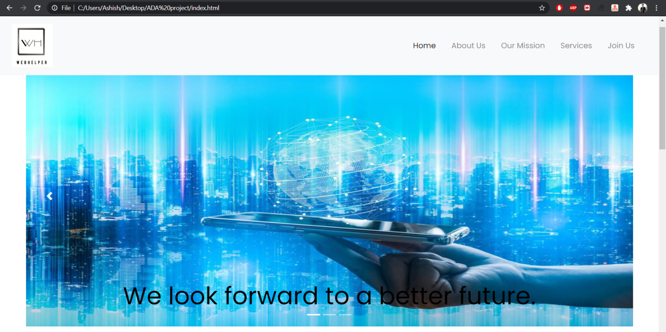

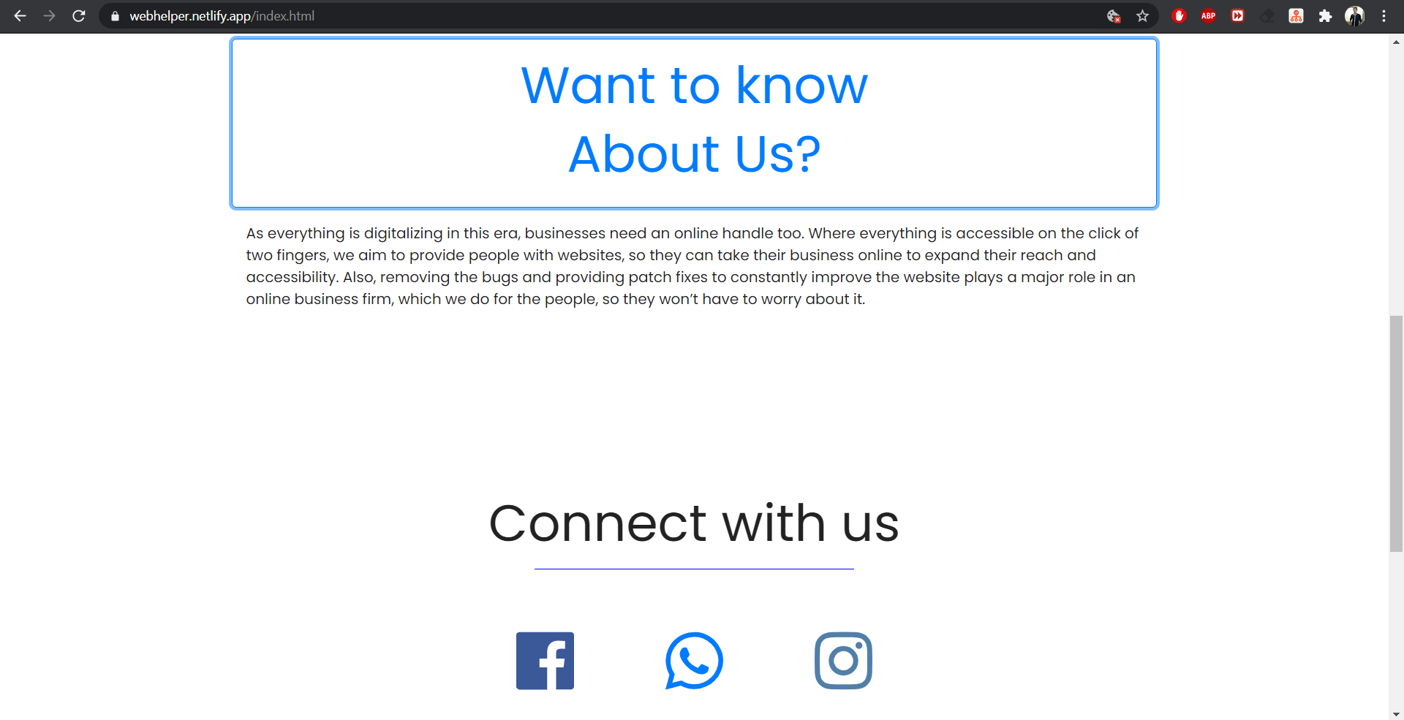

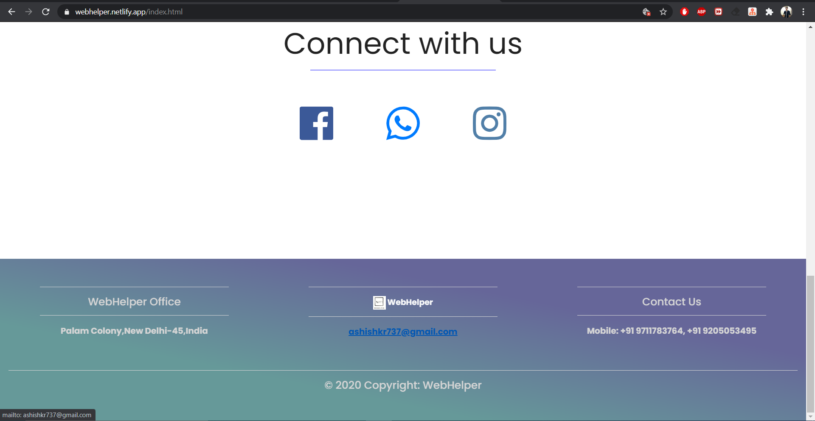

* This is the About Us page of our website

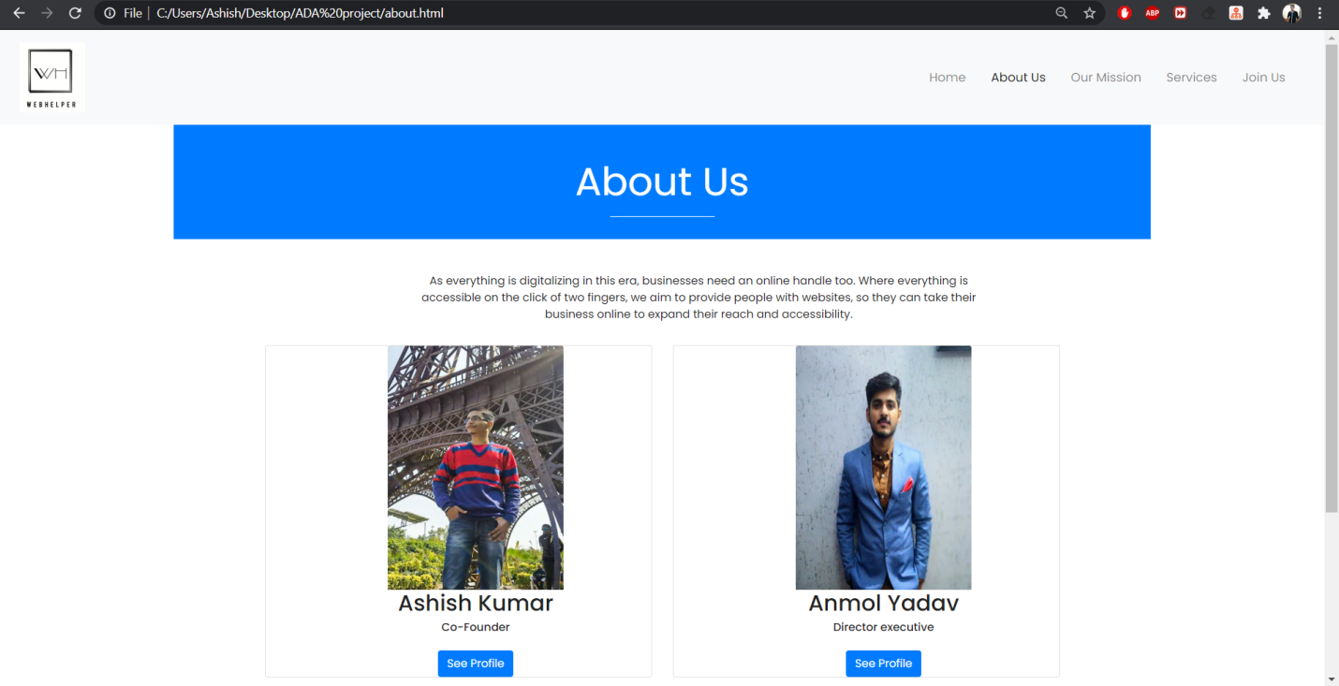

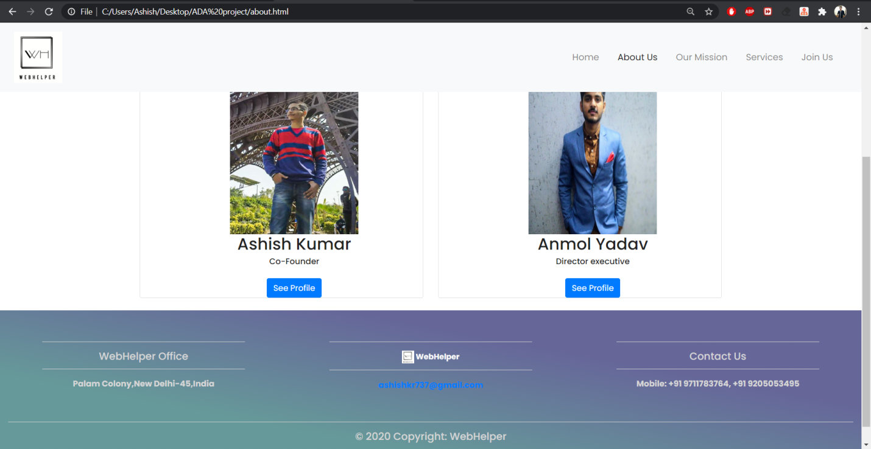

Website link: https://webhelper.netlify.app

**EXPLANATION OF WORKING MODEL TILL NOW**

Till now the website’s home and about us page has been completed.

Header of the website has these two clickable options: ‘Home’ and ‘About us’.

And then it has slideshow of 3 slides which changes with a set timer and also by the arrow head symbol (for better user experience), depicting company’s goals and motives. This slideshow is implemented by using carousel feature of bootstrap.

Then there is 'Want to know about us' section. When user clicks on that option, then a dropdown will occur which consists of why we chose this topic, and the motivation behind it, and also a highlight of services we would provide to our customers with.

Then there is option to connect with us on different social media platforms, namely Facebook, WhatsApp, and Instagram, as these are the most widely used social media platforms on the internet. On clicking on any of the 3 app icons, a redirect triggers which directly takes user to the profile’s feed or chatbox of the respective web apps. We used these application’s API(s) to implement this feature.

Footer of the homepage has 3 fields, including postal address, email and phone numbers. Footer is implemented by using feature of bootstrap which helps to build footer of the page.

On clicking on the email, it will redirect, and a new mail with a target address is created, without a body. Then user can mail us questioning anything regarding some sort of projects or quality products that we offered.

Then on clicking ‘About Us’ on the header of the website, a new page loads which consists the idea behind starting this company.

There are 2 photographs of the persons behind this website initiative, with name and post in the company.

There is one button under each photograph, clicking on which, a redirect triggers which opens their personal profiles on LinkedIn, and Instagram respectively. We used these application’s API(s) to implement this feature.

Footer of ‘About Us’ has the same information and email redirects as explained in ‘Home’ Page and it is built by using the same feature of bootstrap which helps to build footer of the page.

Further tabs in header section are yet to be design and implement.

The tools and technologies that are used to build the website till now:

Front End Technologies: html, CSS, Bootstrap

Versions of these technologies used: html5, CSS3, Bootstrap 4.0.0

IDE: Visual Studio Code

Website link: https://webhelper.netlify.app

**TIMELINE REPORT**